CS 255 System Design Document Template

UML Diagrams

UML Use Case Diagram
Figure 1. DriverPass UML Use Case Diagram
The use case diagram illustrates how customers, the secretary, the IT officer, the owner, and the external Department of Motor Vehicles (DMV) system interact with DriverPass. The diagram represents customer registration and training package selection, driving lesson reservations, online classes and practice tests, account administration, reservation tracking and reporting, and DMV content updates. Administrative functions are separated according to user roles. Access to online classes and practice tests is associated with Package Three, which includes online learning materials and practice tests.
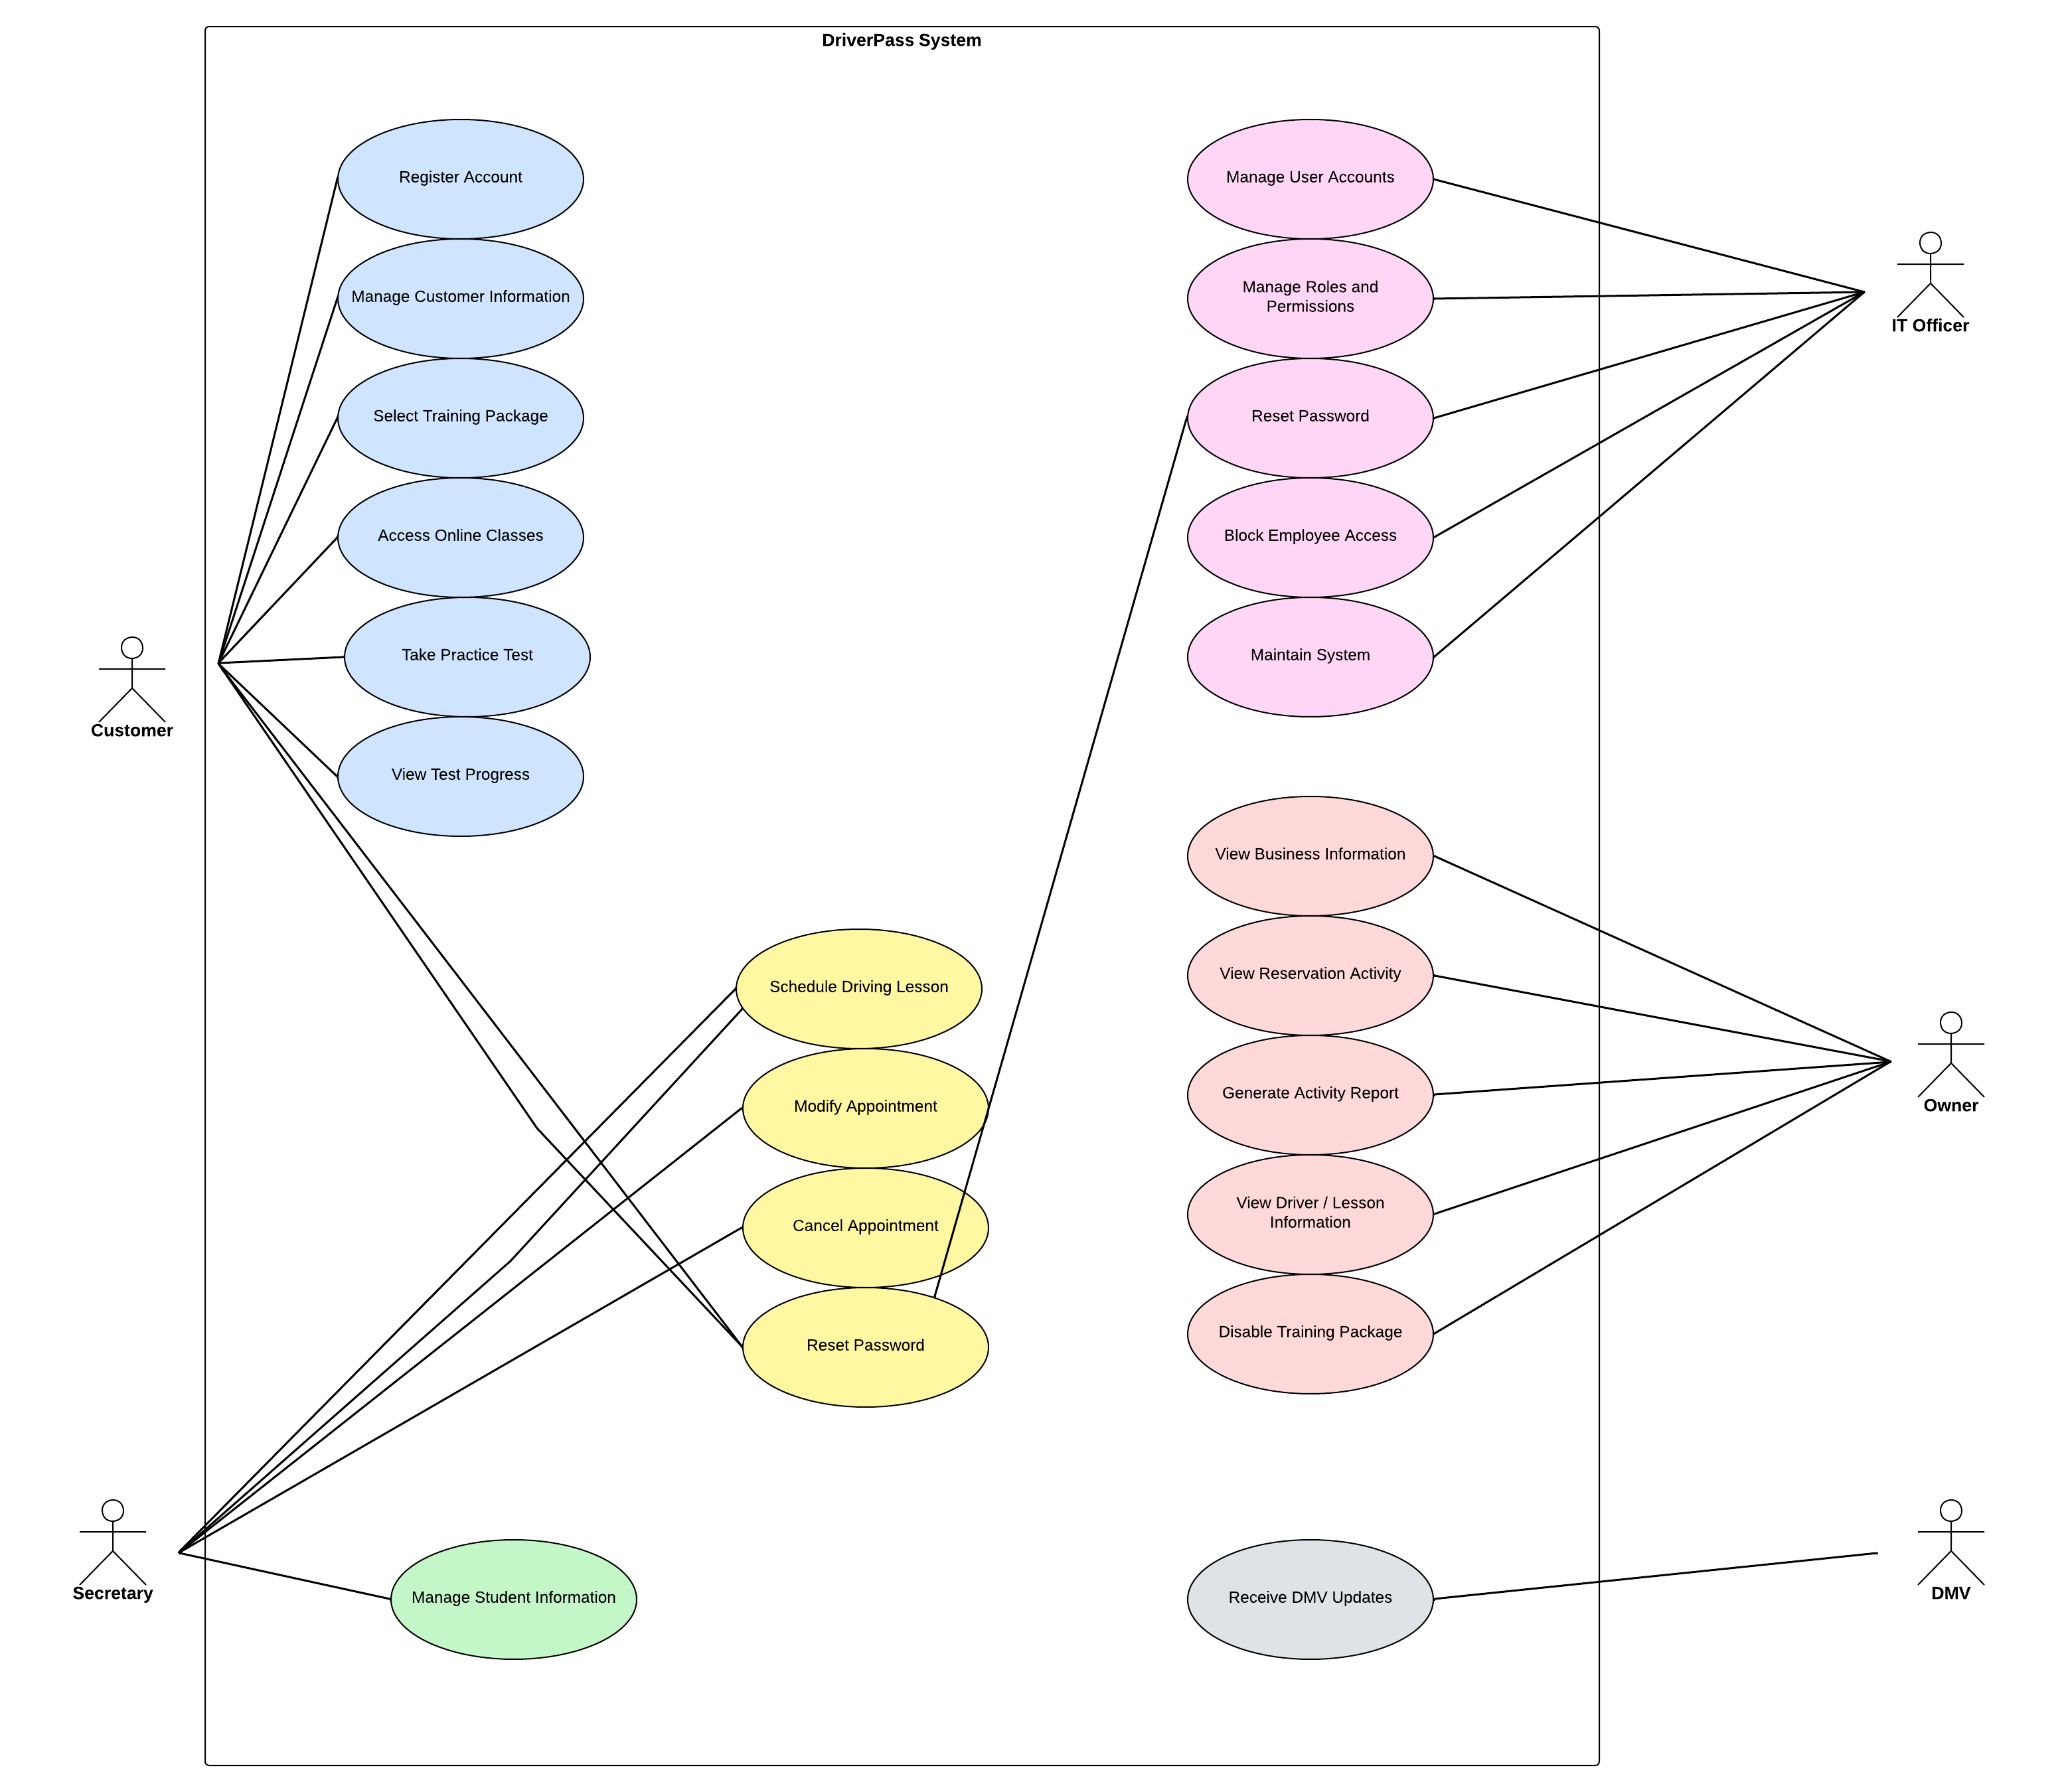

UML Activity Diagrams
Figure 2. UML Activity Diagram for Scheduling a Driving Lesson
This activity diagram illustrates the process of scheduling a driving lesson through DriverPass. A customer can request an appointment online, or the secretary can enter a reservation on the customer's behalf. The requester provides or confirms the appointment details and selects a preferred date and time. The system checks the availability of a driver and vehicle for the requested two-hour session. If availability is confirmed, the system assigns the driver and vehicle, saves the reservation, records the reservation activity, and confirms the appointment. If the requested time is unavailable, the requester is notified and can select another date or time. The process supports reliable scheduling and the client's requirement to track reservation activity.
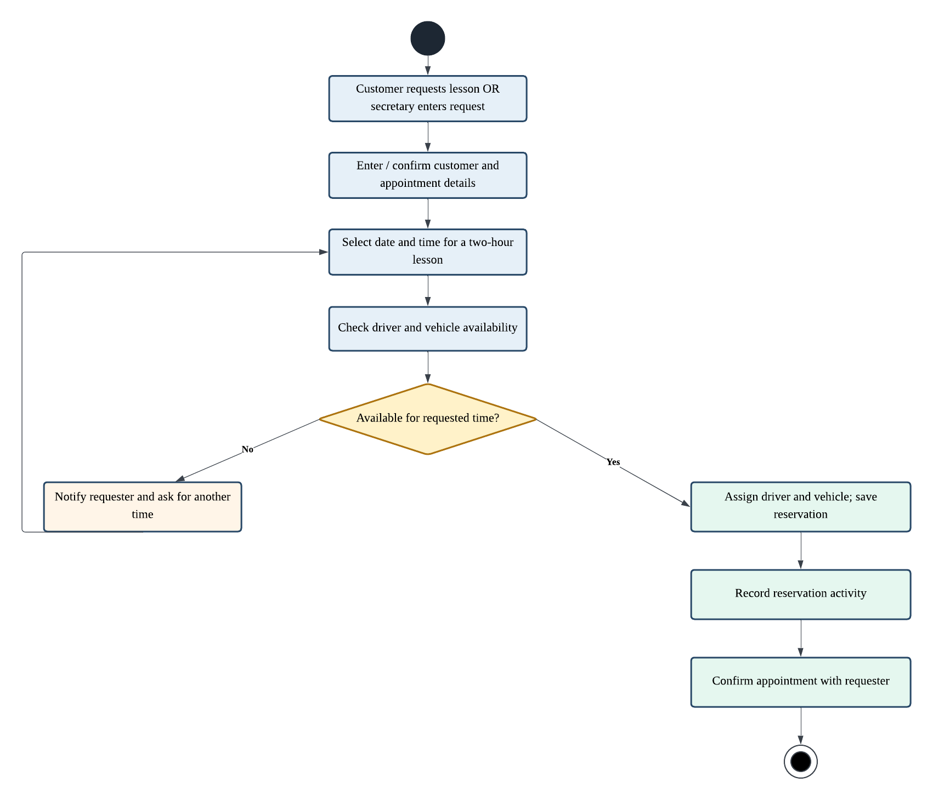

Figure 3. UML Activity Diagram for Completing an Online Practice Test
This activity diagram illustrates how a customer enrolled in Package Three completes an online practice test. The customer signs in and opens the practice-test area. The system checks whether the customer's package includes access to online practice tests. If the customer is eligible, the system displays available tests, and the customer selects and starts a test. The system records the test as in progress. After the customer submits the completed test, the system records the score, time taken, completion information, and resulting status. The customer's test progress is then updated for review. If the customer is not eligible, the system explains that online practice tests require Package Three and ends the process without starting a test.
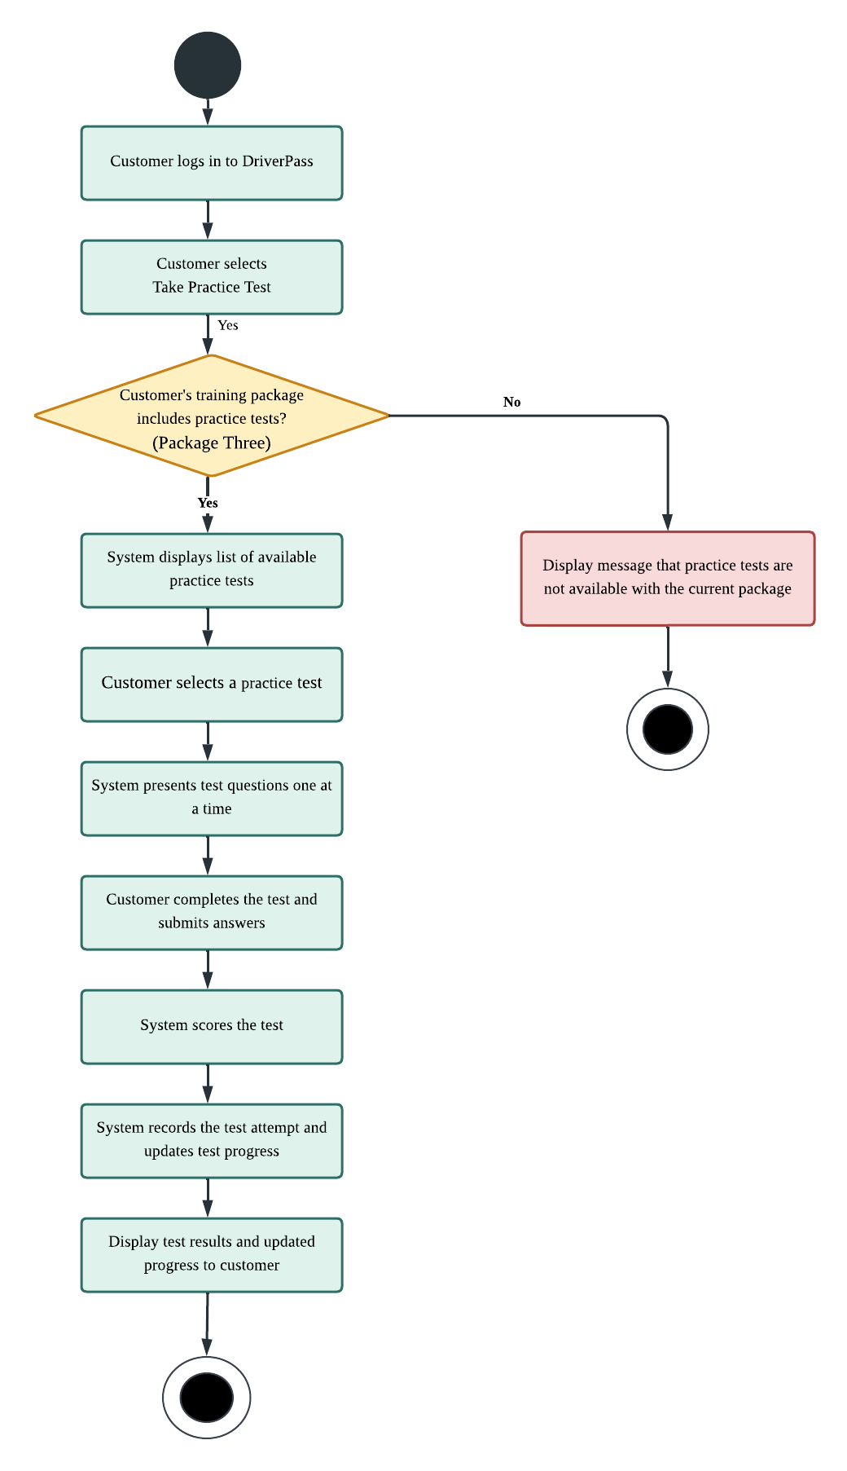

UML Sequence Diagram
Figure 4. UML Sequence Diagram for Scheduling a Driving Lesson
The sequence diagram illustrates the interactions involved in creating a driving lesson reservation. The customer or secretary submits the requested appointment details through the DriverPass interface. The system checks the availability of a driver and vehicle for the selected time. If availability is confirmed, the reservation is saved, the reservation activity is recorded, and a confirmation is returned to the requester. If the requested time is unavailable, the system communicates the issue and allows the requester to submit another date or time. The sequence demonstrates how the system supports two-hour lessons, driver and vehicle assignments, and reservation accountability.
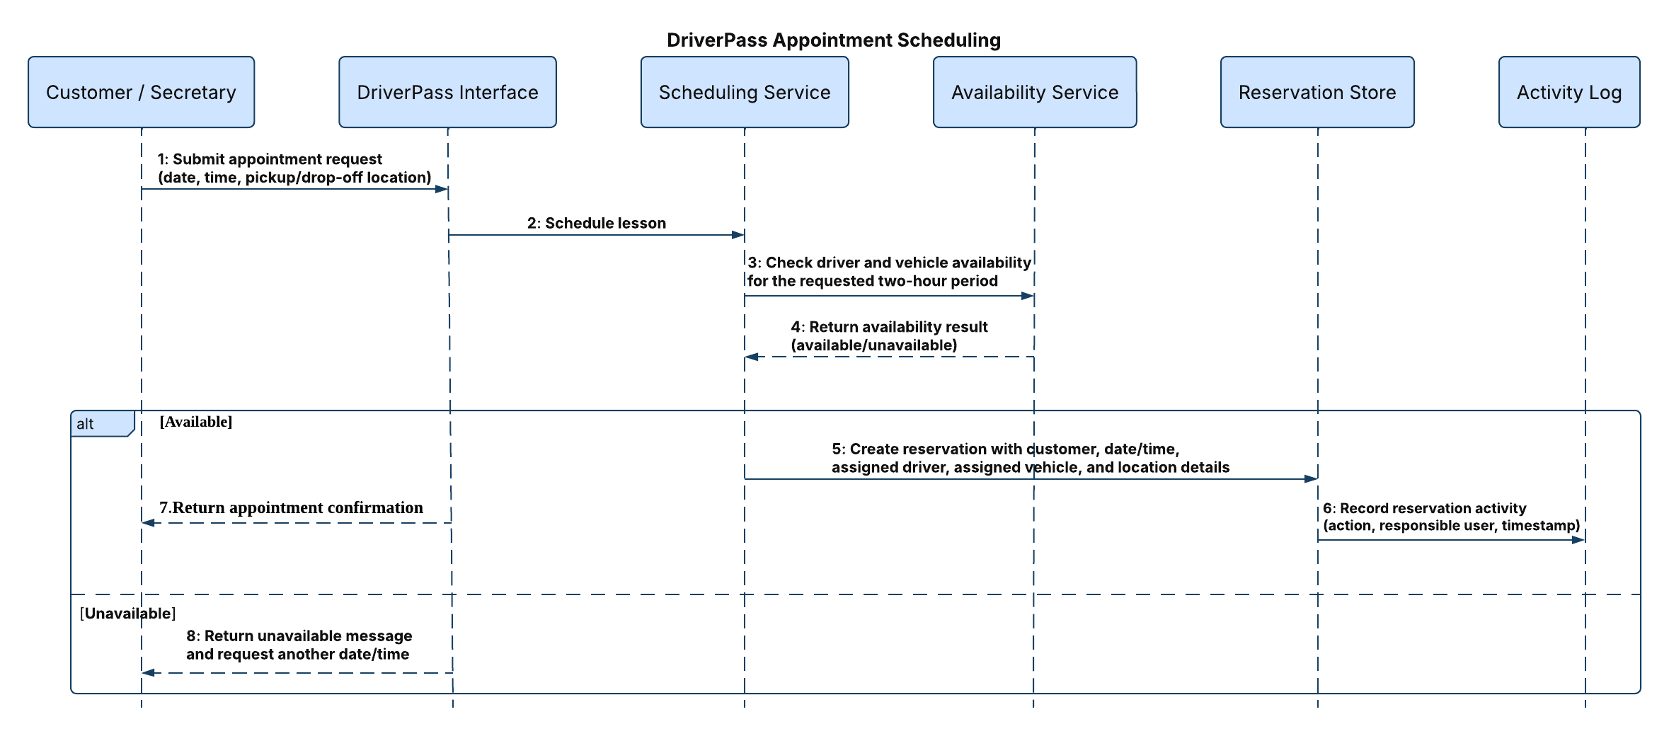

UML Class Diagram
Figure 5. DriverPass UML Class Diagram
The class diagram represents the main information structures required to support DriverPass. It includes customer profiles, user accounts, training packages, driving lesson appointments, drivers, vehicles, practice tests, test attempts, and reservation activity records. Their attributes support appointment scheduling, package eligibility, online test progress, driver and lesson information, role-based access, and accountability for reservation changes. Relationships between the classes show how customer appointments, assigned drivers and vehicles, test attempts, and activity records are connected. Sensitive account and payment information must be handled securely.
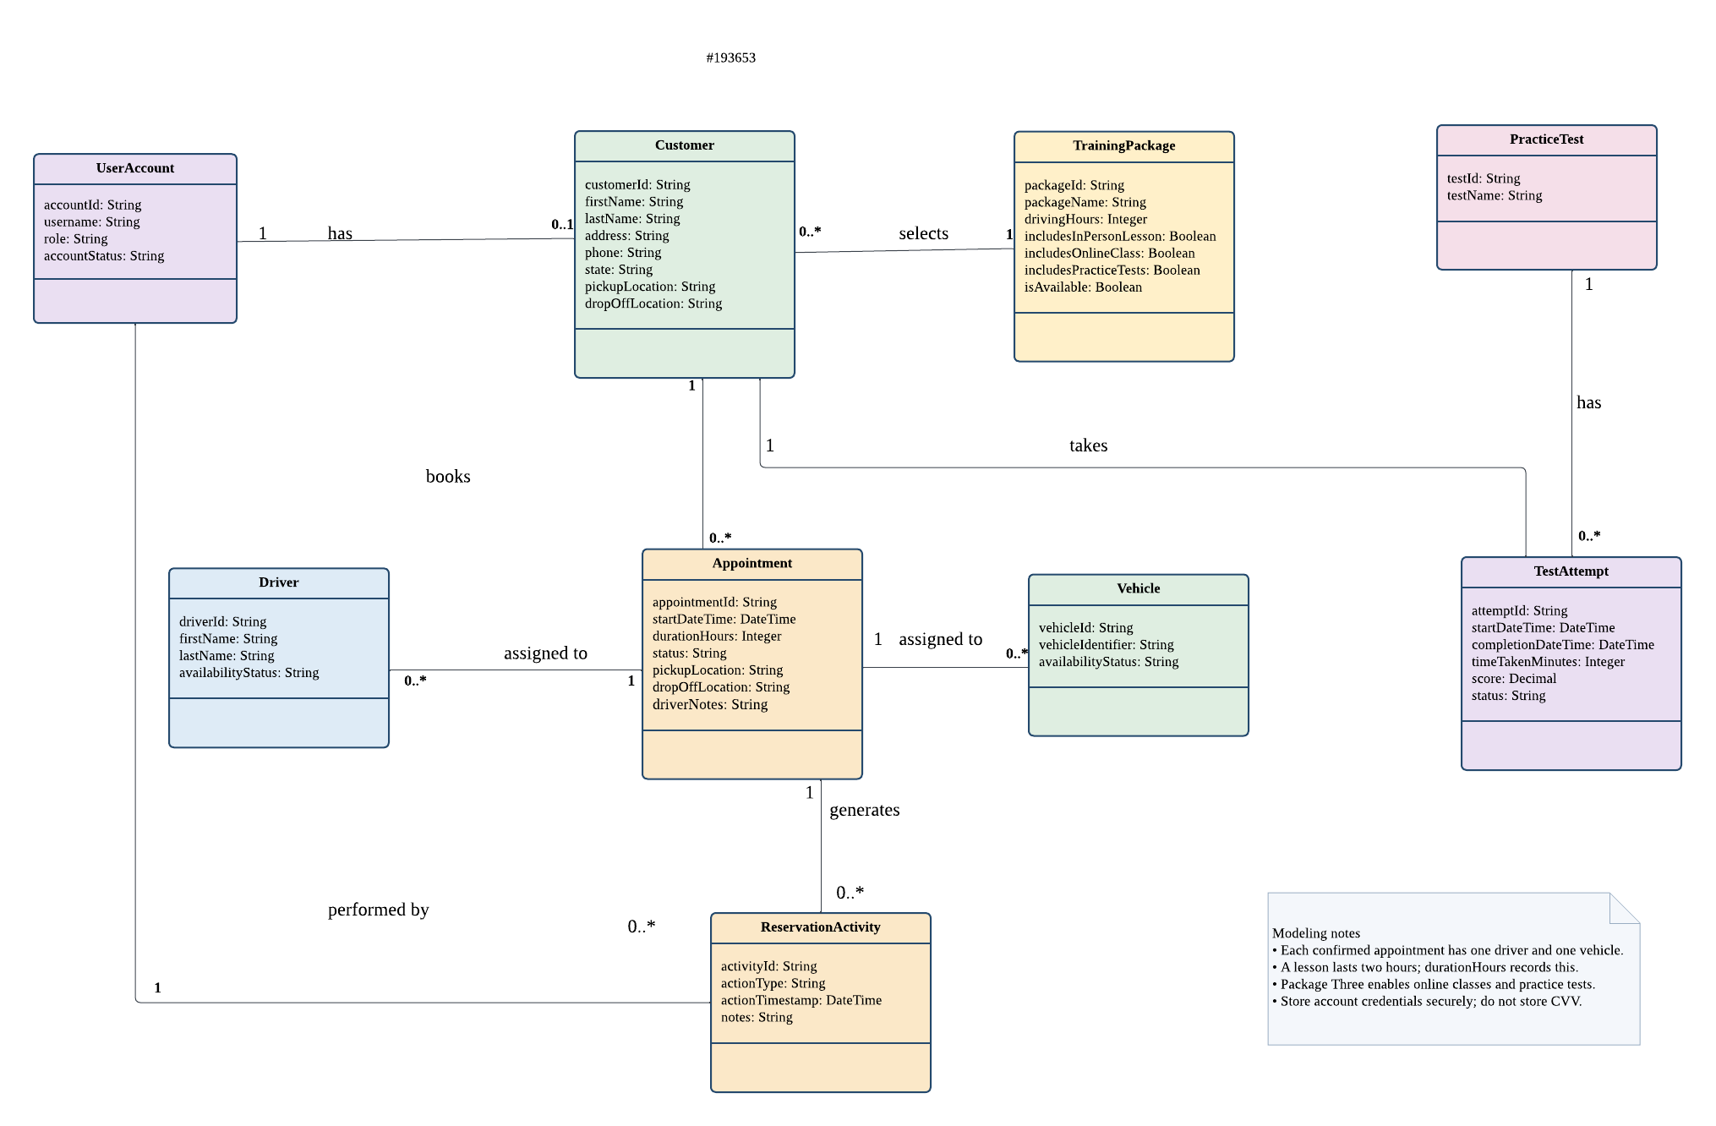

Technical Requirements

Hardware and User Access

DriverPass should be accessible through a web browser on desktop and mobile devices so that customers and employees can use the system from different locations. Users need a compatible device and an internet connection to create or modify shared records. The client also requires the ability to download reports and data for use in spreadsheet software such as Microsoft Excel. A printer may be used when a physical copy of a reservation activity report is needed.
Software and Application Functions

The system should provide a browser-based interface supported by a central data store for customer profiles, user accounts, training packages, appointments, driver and vehicle assignments, practice-test attempts, test progress, driver notes, and reservation activity. Customers should be able to register, select a training package, schedule or manage driving lessons, access eligible online learning materials, and review practice-test progress. The secretary should be able to enter and manage reservations on a customer's behalf.
The scheduling function must support two-hour driving lessons and check driver and vehicle availability before confirming a reservation. Each confirmed appointment should identify the customer, assigned driver, assigned vehicle, date and time, and pickup and drop-off locations. The system should enforce the client's requirement that the pickup and drop-off locations match and prevent conflicting driver or vehicle assignments.
Training-package functionality must represent the three packages described in the interview. Package One includes six hours of in-car training; Package Two includes eight hours of in-car training and an in-person lesson on DMV rules and policies; and Package Three includes twelve hours of in-car training, an in-person lesson, online course content, and practice tests. The owner must be able to disable a package so that new customers cannot register for it. Package customization is outside the scope of the current release.

Data Management and Reporting

The system must maintain reservation history identifying who created, canceled, or last modified a reservation and when the action occurred. Authorized users should be able to view reservation activity and produce a printable activity report. The system should also maintain driver comments and lesson times, along with practice-test information such as test name, time taken, score, and status.

Data Access and Offline Work

DriverPass should allow authorized users to access system information through the web from computers and mobile devices. Users should be able to download reports and selected information for use outside the system, including in spreadsheet software such as Microsoft Excel. Shared records must be created or modified while connected to the system so that updates are centralized and conflicting changes are avoided. Downloaded information may be used offline, but changes made to downloaded copies should not be treated as updates to the central DriverPass records unless an approved process is established.

Security and Account Administration

The system must enforce role-based permissions for customers, the secretary, the owner, and the IT officer. The IT officer must be able to administer user accounts, reset passwords, and block employee access. Customers must be able to reset forgotten passwords through the system. Access to customer information, administrative functions, and reservation reports should be restricted to authorized users.
Customer registration involves payment-card information. As an implementation recommendation, DriverPass should use a suitable secure payment-processing service and avoid retaining card security codes (CVV). Sensitive information should be protected in transit and at rest, and passwords should be stored using appropriate secure password-hashing practices rather than in plaintext.

Infrastructure, Maintenance, and External Updates

The client prefers a cloud-hosted web application and expects the service to handle backups and security with minimal technical problems. The infrastructure should support reliable access, data backup and recovery, monitoring, and routine software maintenance. Specific hosting providers, availability targets, backup schedules, and recovery-time requirements have not yet been established and should be confirmed during implementation planning.
DriverPass must support updates to DMV rules, policies, and sample questions, and notify users when relevant updates are available. The interview identifies the need for this connection but does not specify the integration method. The technical design should therefore confirm whether updates will be obtained through an official interface, an authorized data feed, or a controlled administrative process before implementation.

Development and Verification Tools

A UML modeling tool such as Lucidchart can be used to create and maintain the use case, activity, sequence, and class diagrams. Implementation tools should be selected after the client confirms the hosting environment and technical constraints. Testing should verify role permissions, password-reset workflows, appointment availability and conflict prevention, two-hour lesson scheduling, matching pickup and drop-off locations, reservation audit history, report generation, package eligibility, practice-test progress, and DMV content updates.

